# School of Computer Science

## UNIVERSITY OF PETROLEUM AND ENERGY STUDIES DEHRADUN, UTTARAKHAND



Continuous Integration and Continuous Delivery Lab

# Lab File (2023-2024)

**for**

**5th Semester**

## Submitted To:

Dr. Hitesh Kumar Sharma

## Submitted By:

Dhruv Agarwal

B. Tech. CSE

[DevOps]

500093041

R2142210273

B2- DevOps (Non-Hons)

## LAB EXERCISE - 1

**Aim:**

1. **Create a Maven Project in eclipse.**

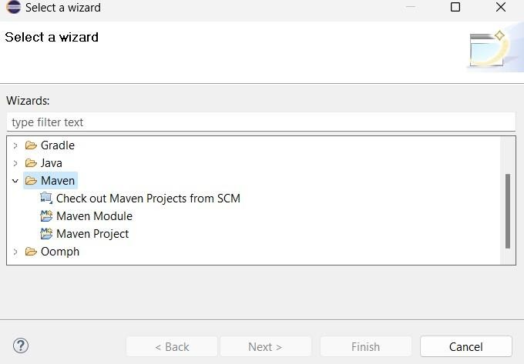

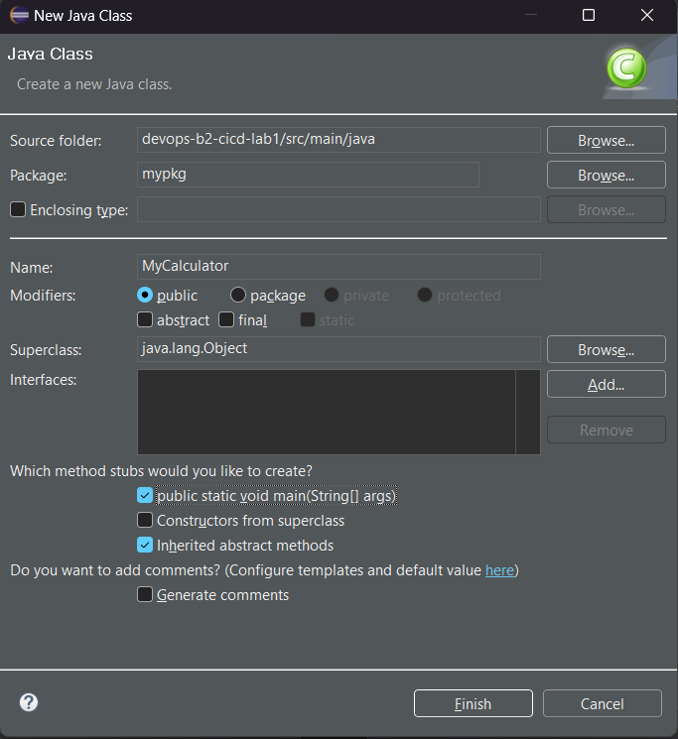

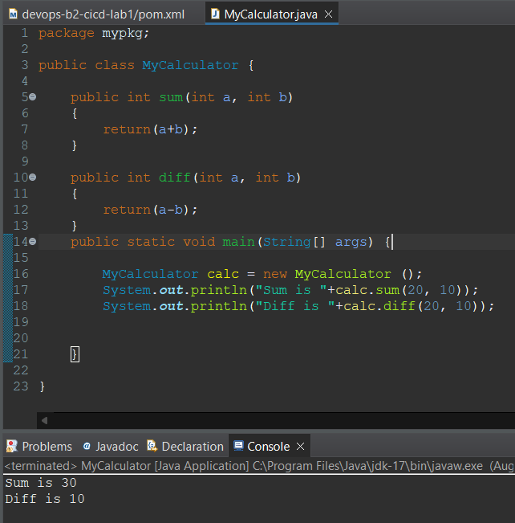

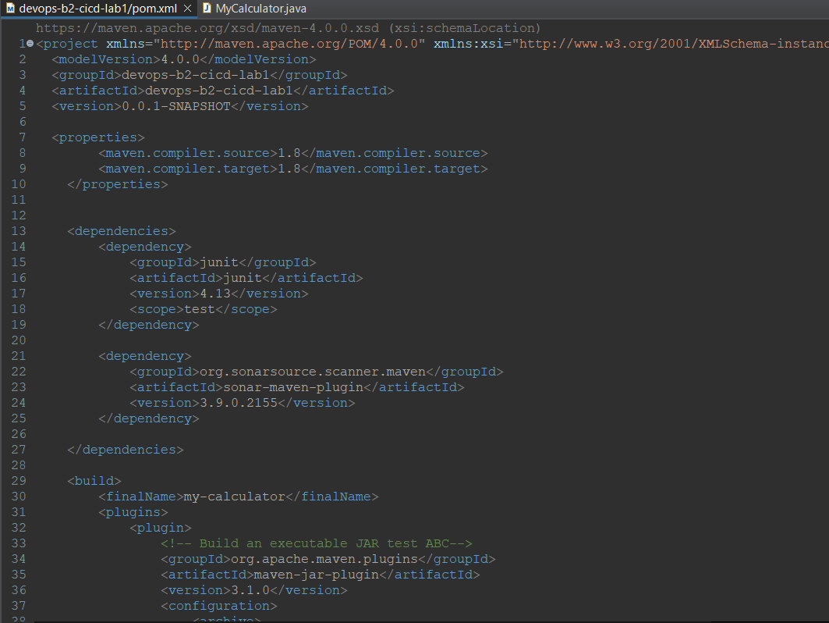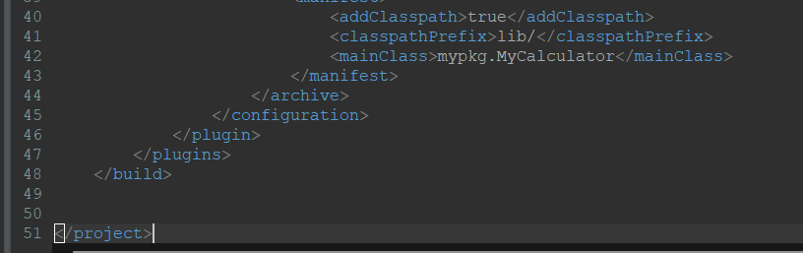

1. **Push project on github.**

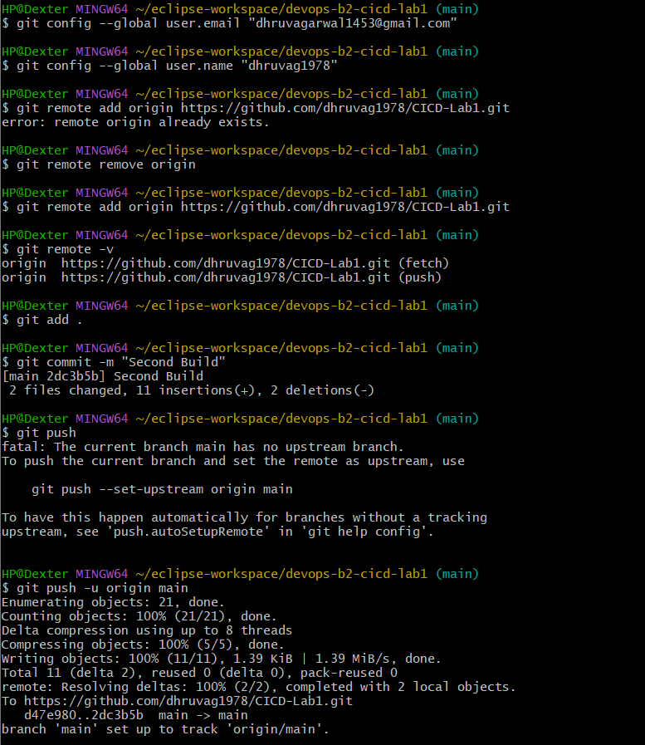

1. **Start Jenkins and add maven Integration Plugin and create a maven project name as “Cicd-lab1” and add URL of our repo in github and configure it.**

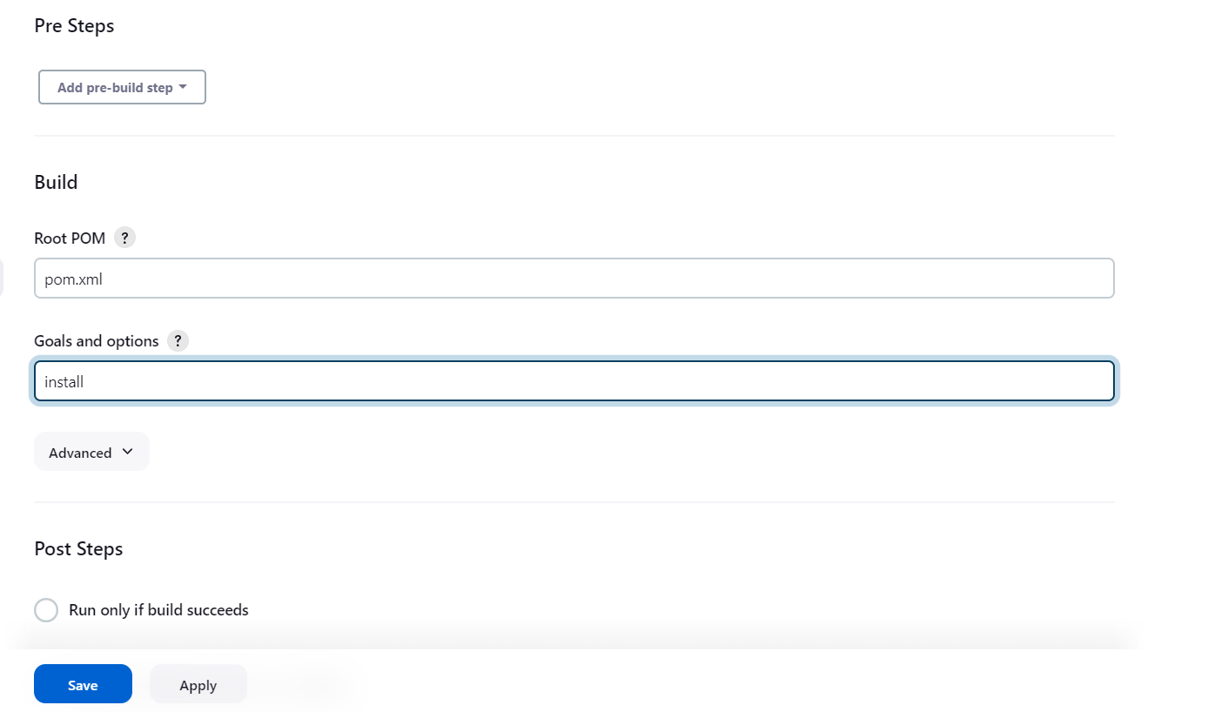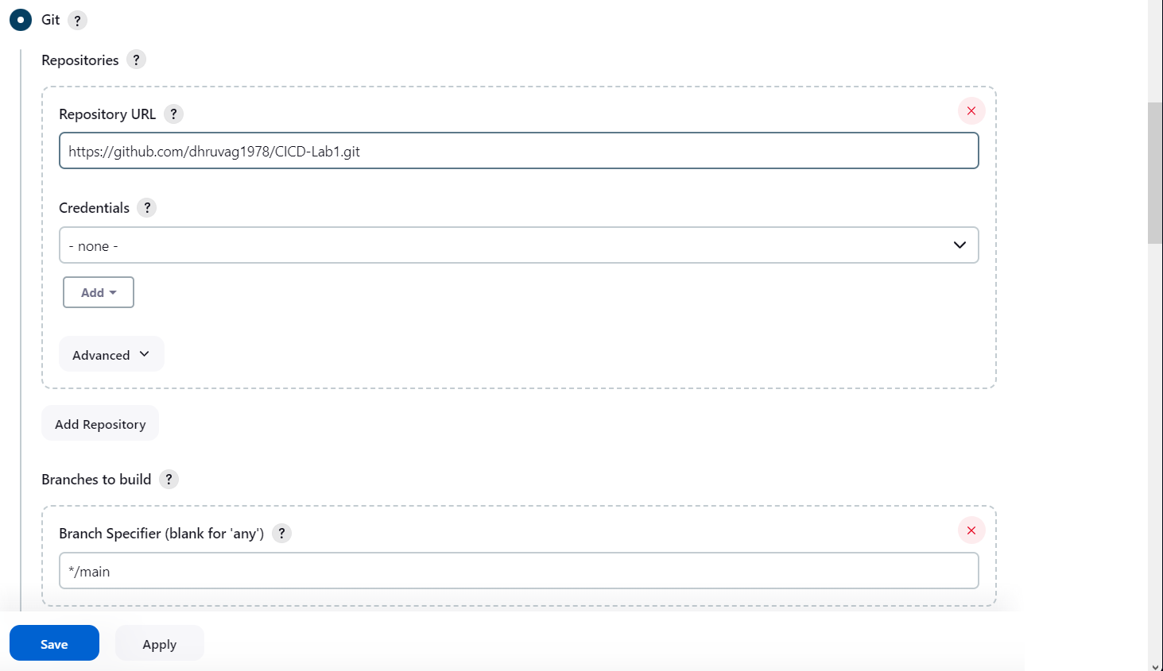

1. **Now Build it.**

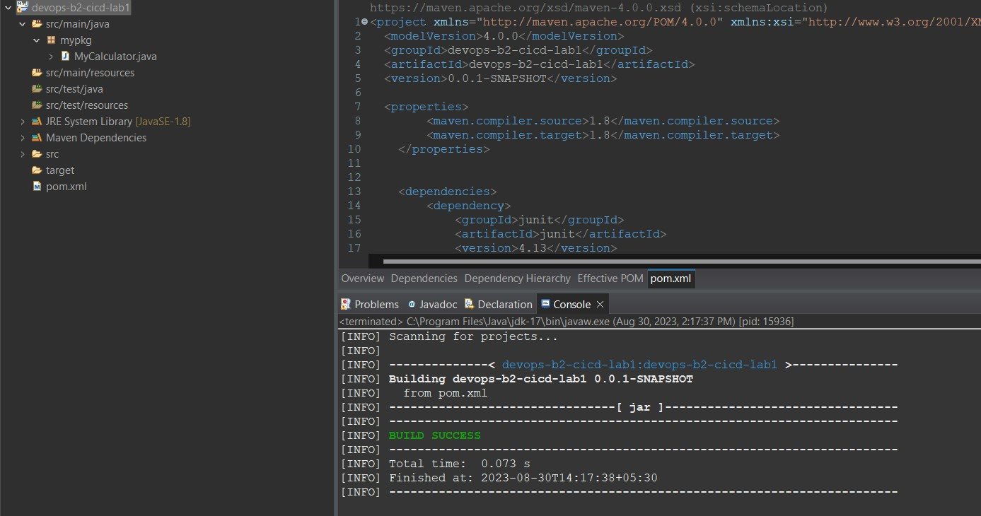

1. **edit the code and add poll scm in jenkins configuration then again commit and push it.**

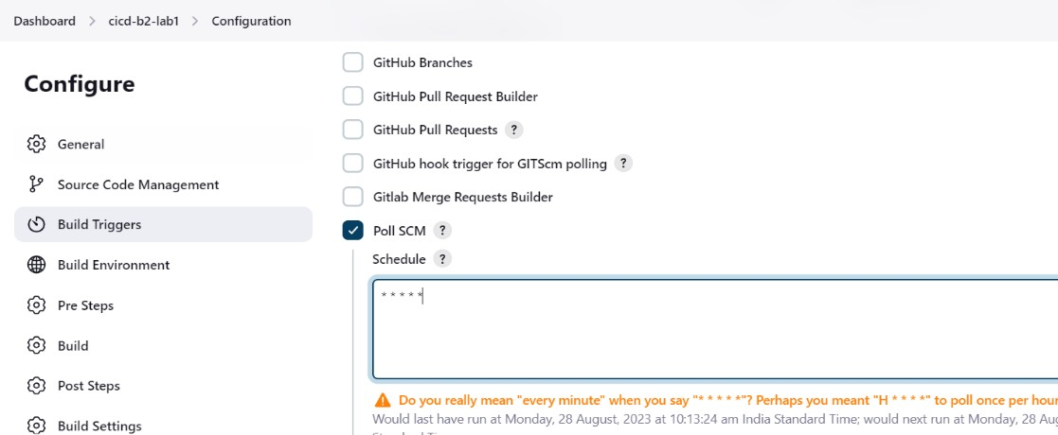

1. **After push we can see it will make automatic build.**

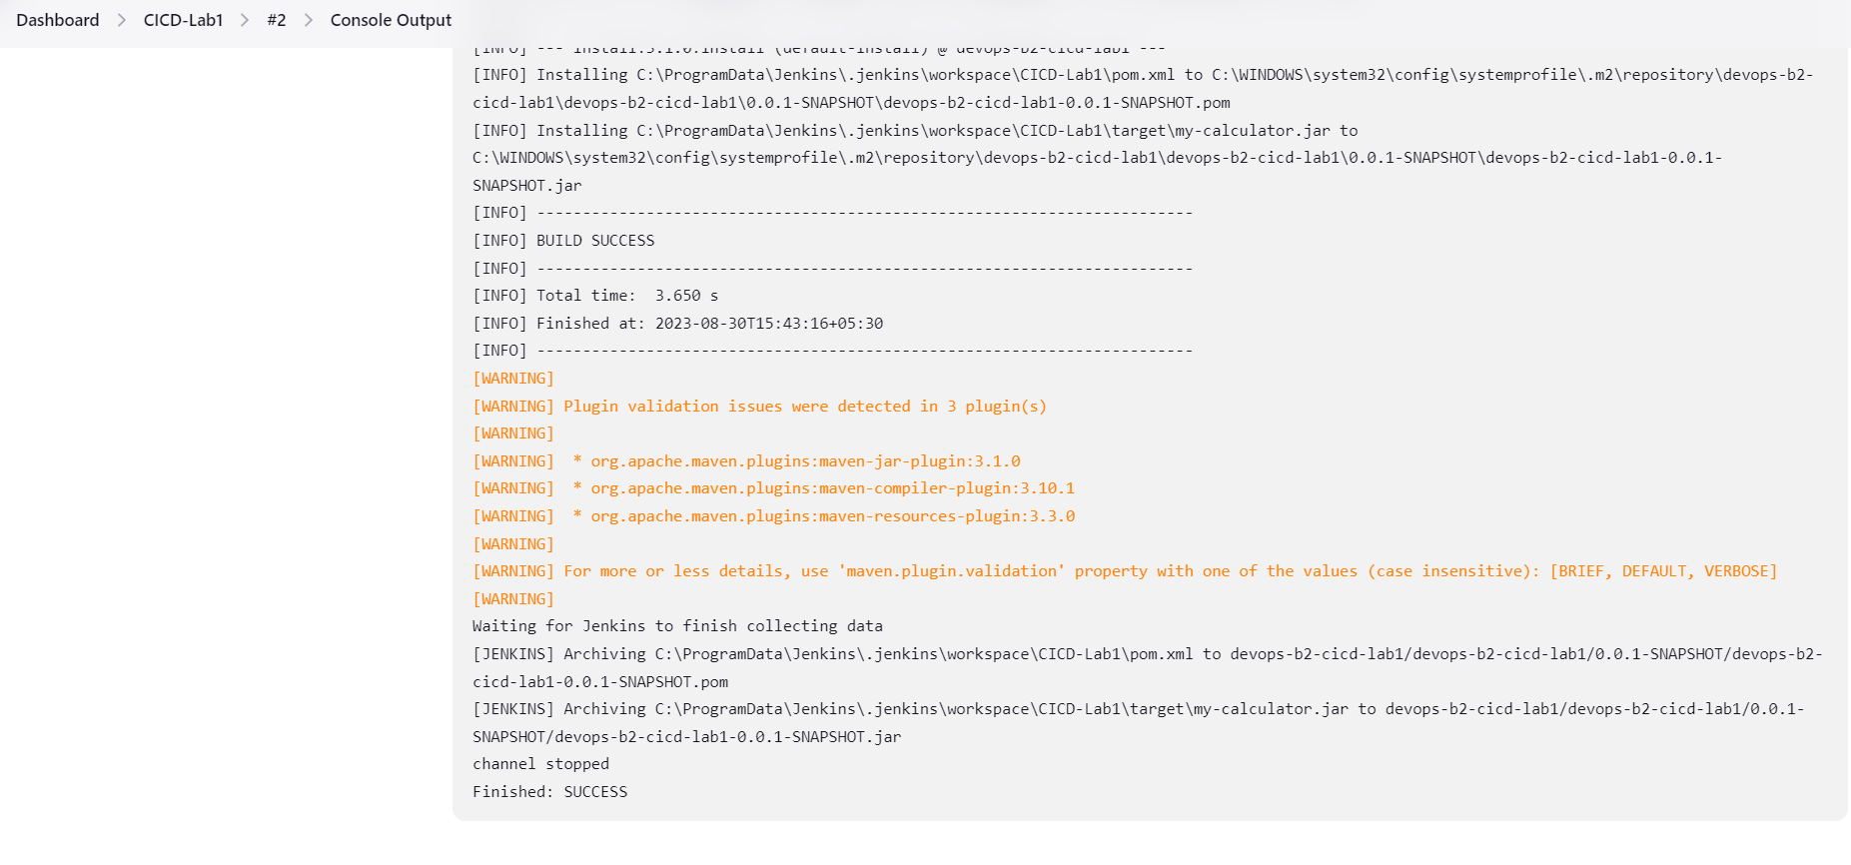

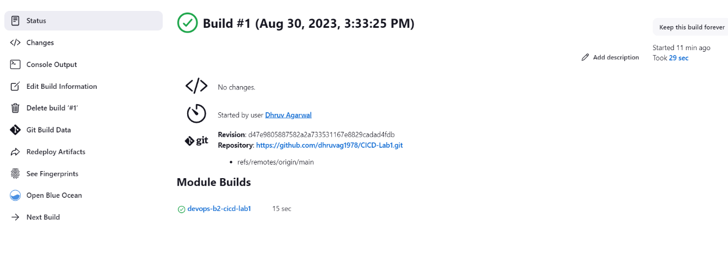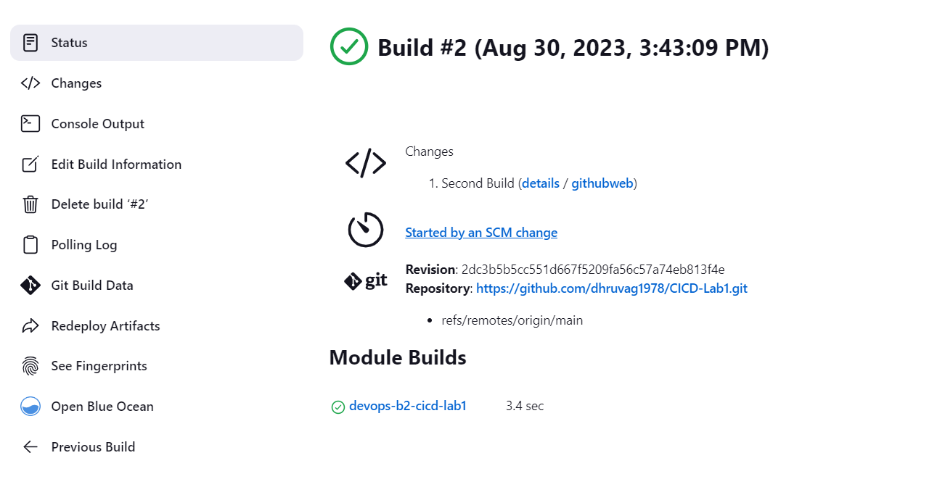

## LAB EXERCISE - 2

**Aim: Creating a Jenkins Pipeline with a Jenkins file.**

1. **Create a Maven Project in eclipse.**



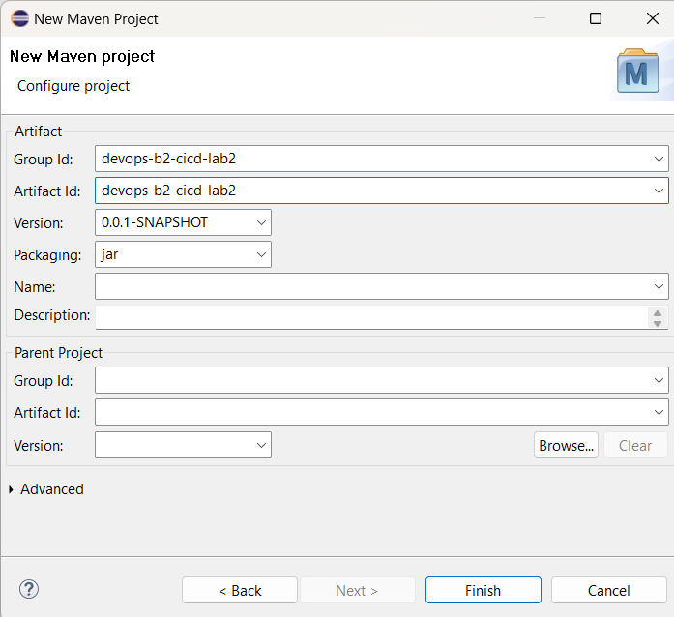

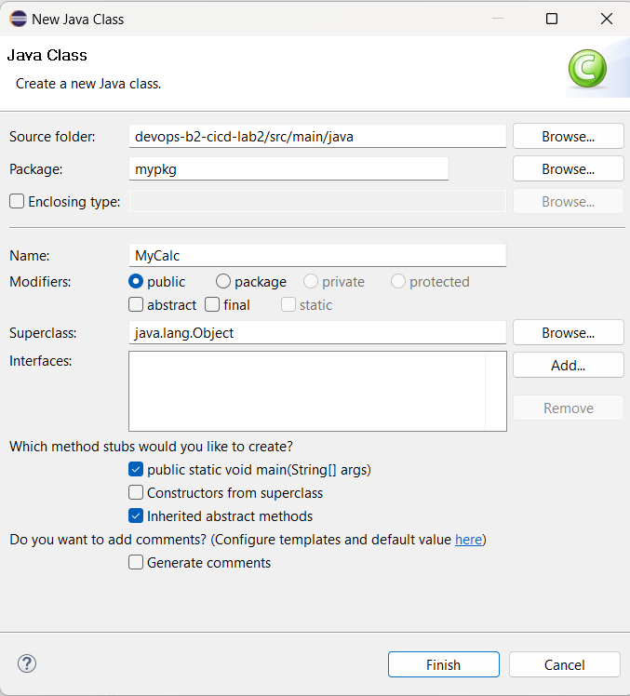

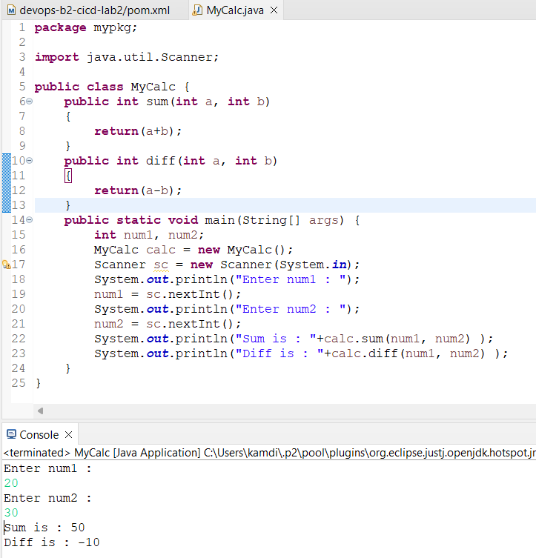

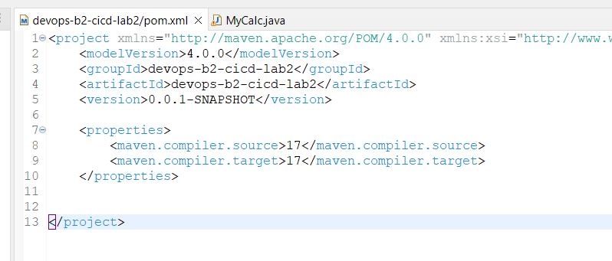

1. **Make a repo name as “CICD-Lab2_Jenkinsfile” and Push project on github.**

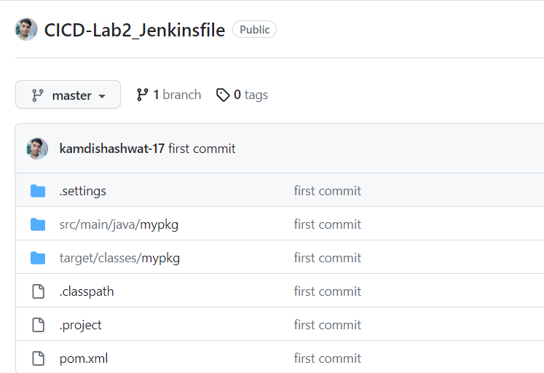

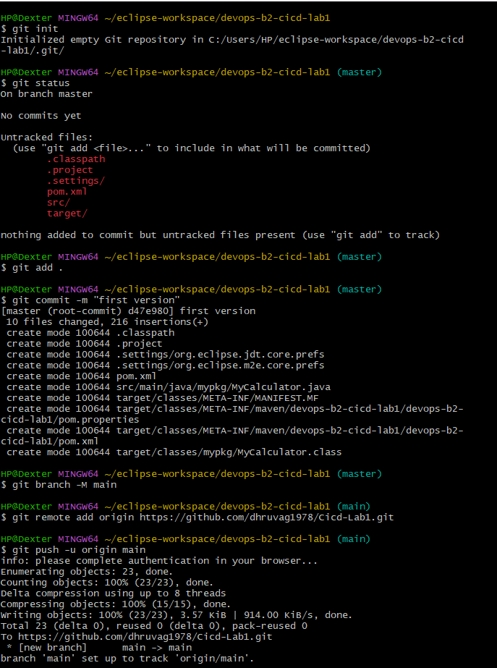

1. **Add Maven integration and Git plugin in Jenkins, configure repo and make a build**

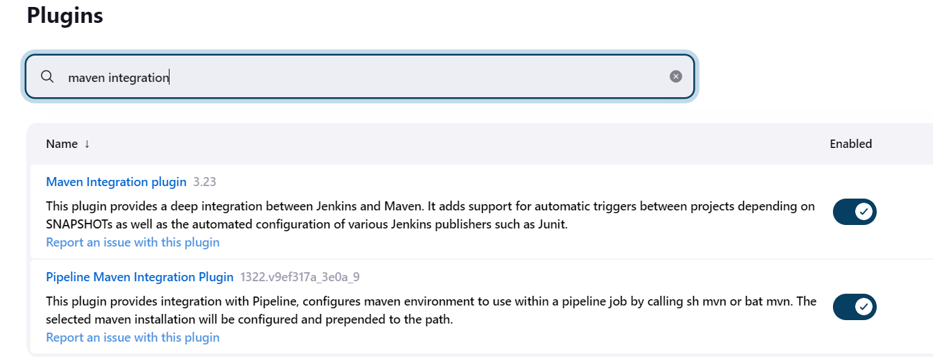



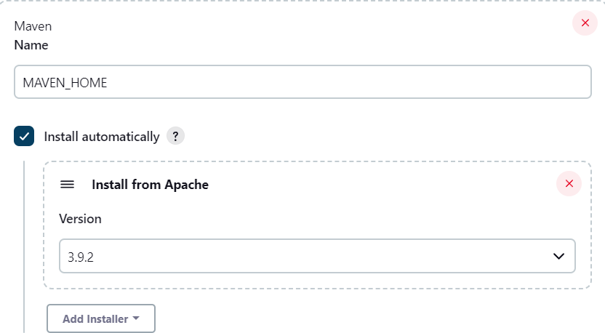

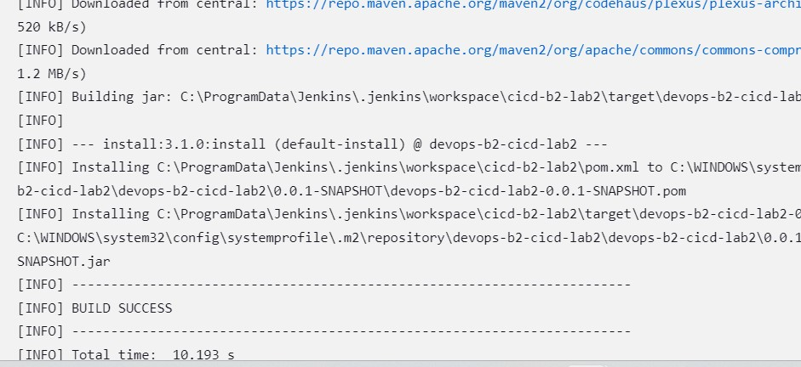

1. **edit the code ,add mul funcion and add poll scm in jenkins configuration then again commit and push it.**

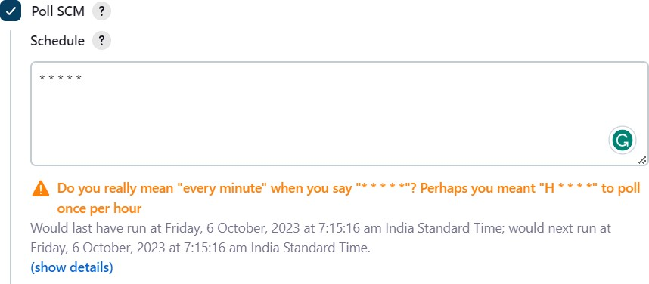

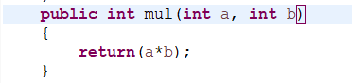

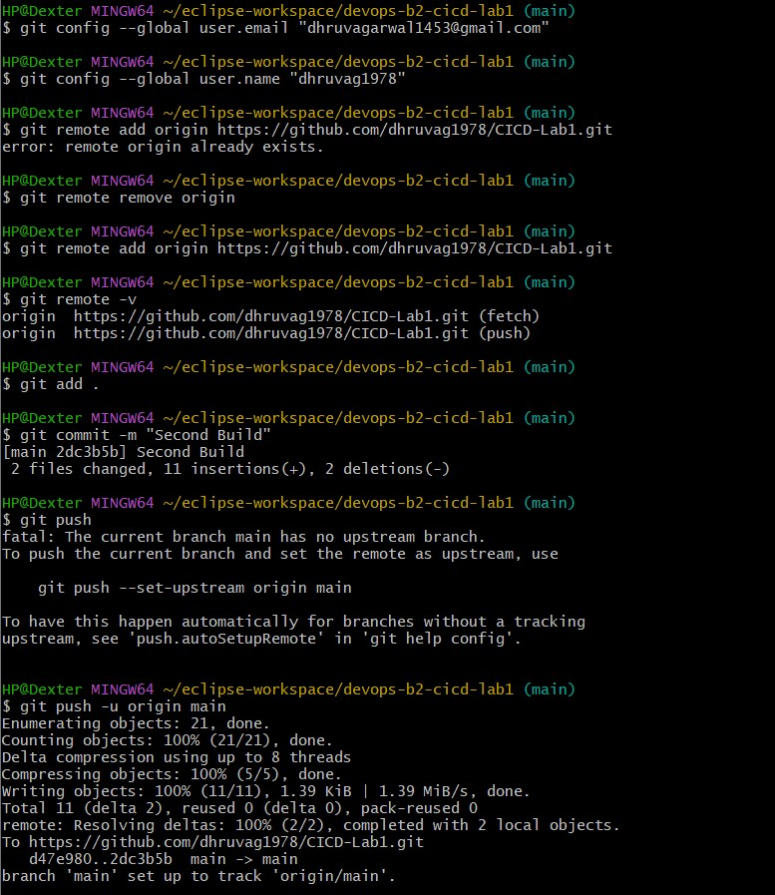

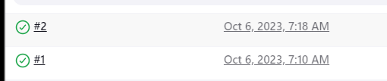

**5] Add Jenkins file then commit and push it , In Jenkins make pipeline add configure it. When you create a pipeline. The pipeline will start.**

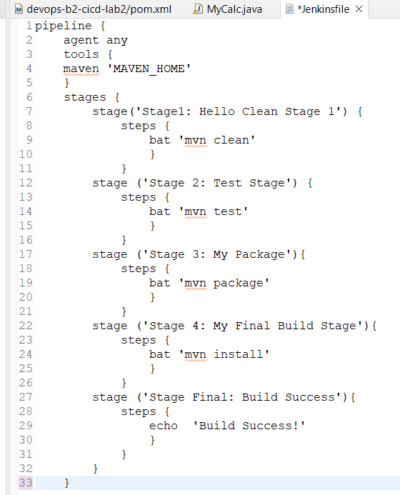

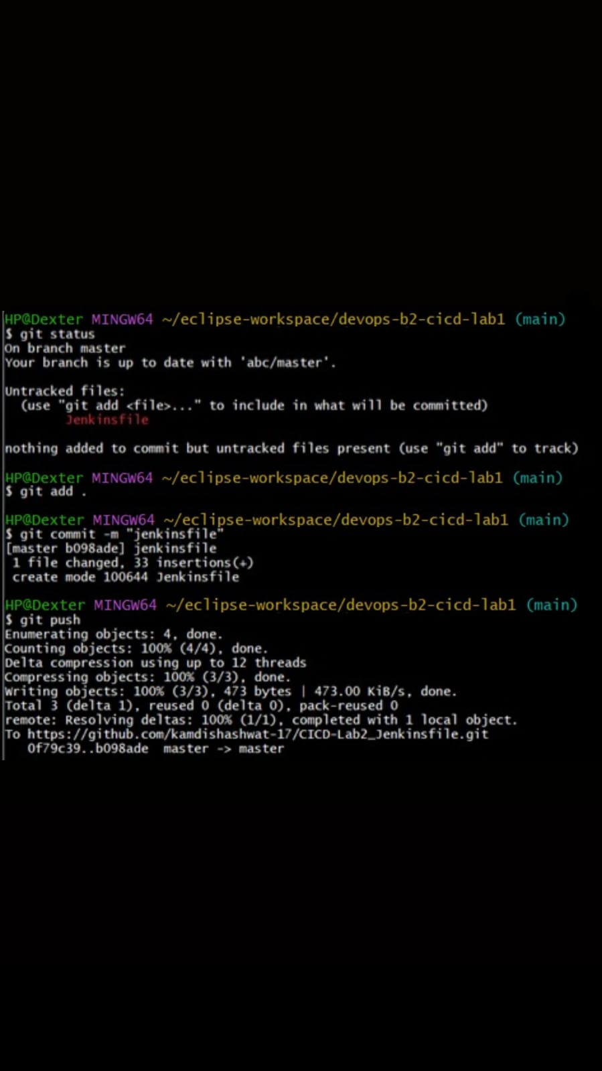

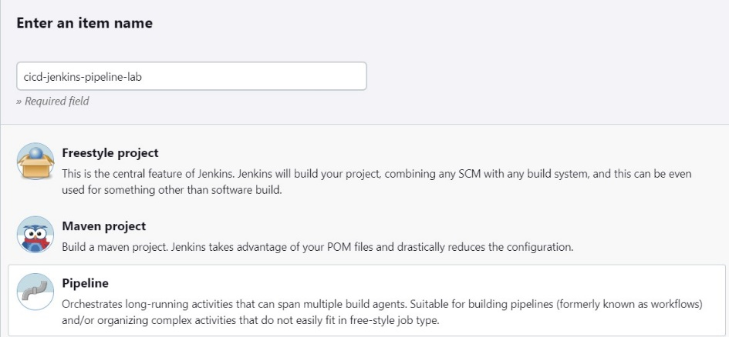

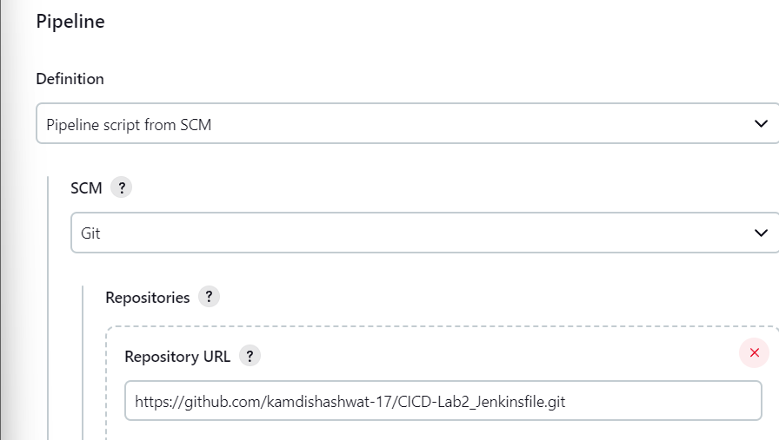

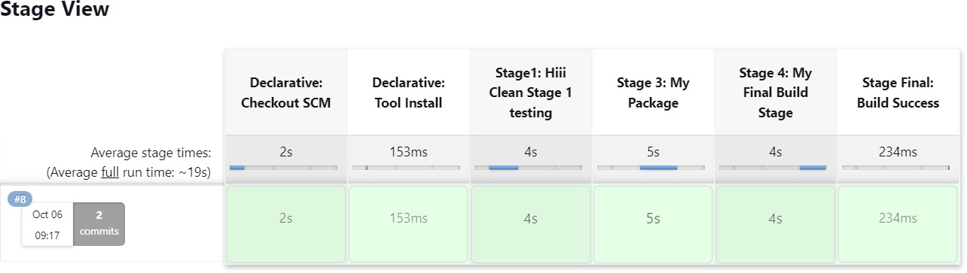

## LAB EXERCISE – 3

**Aim: Maven Build using GitHub Actions**

1. Push our file on git repo name as CICD-lab3 which contain class file, dockerfile, pom.xml file and so on.

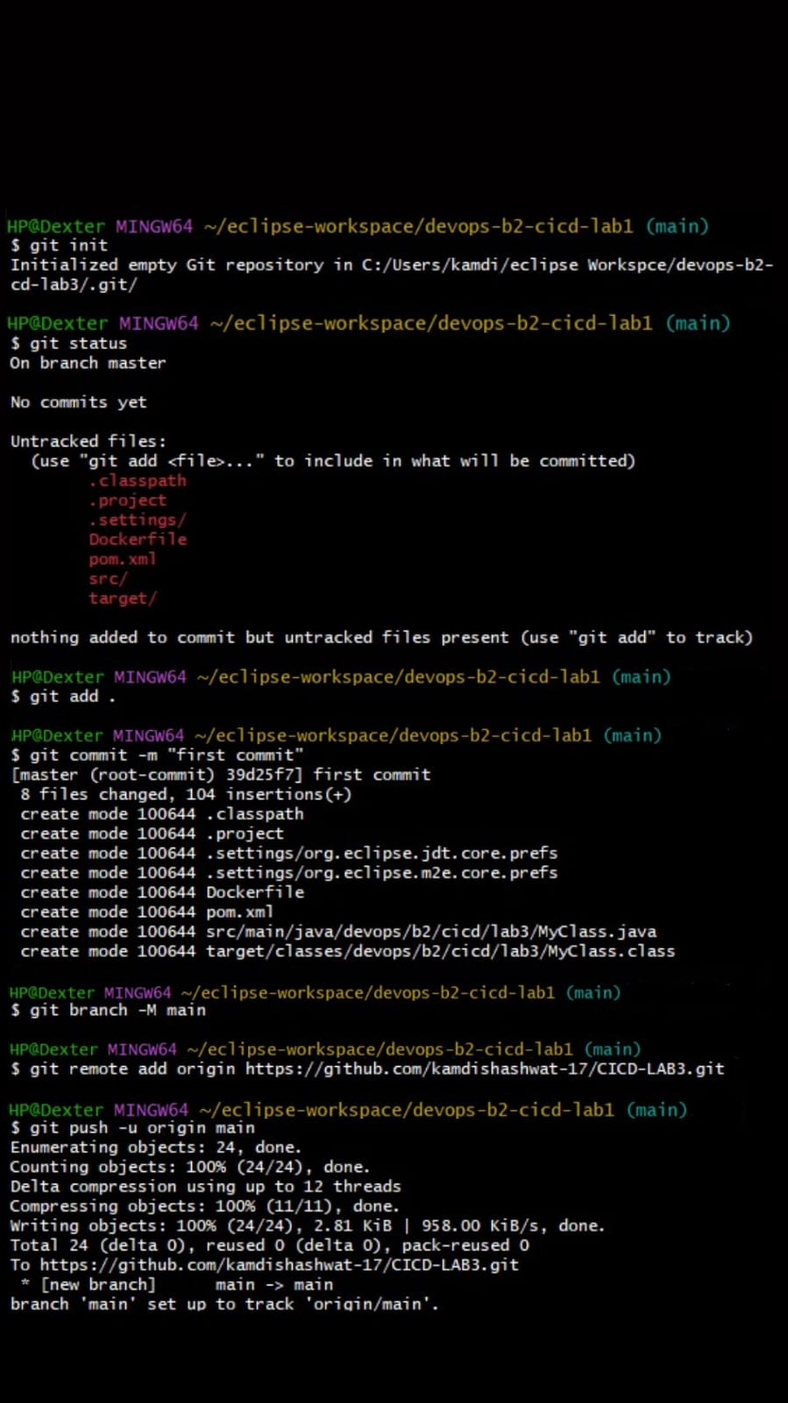



Docker file

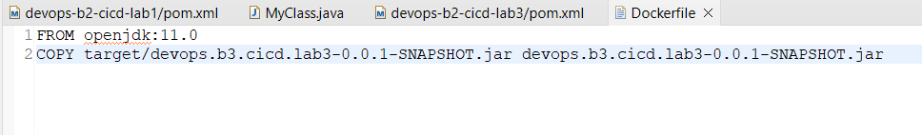

MyClass.java file:

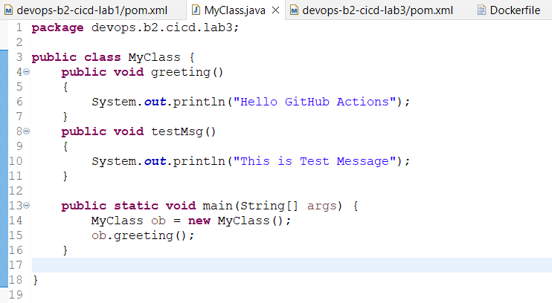

Pom.xml file:

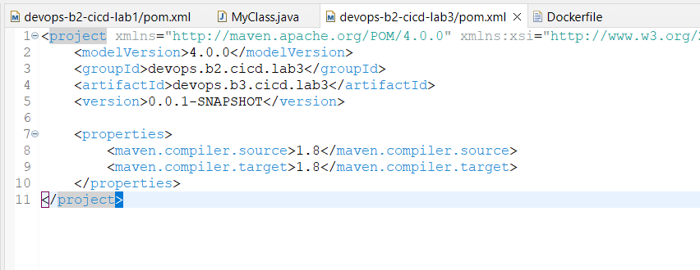

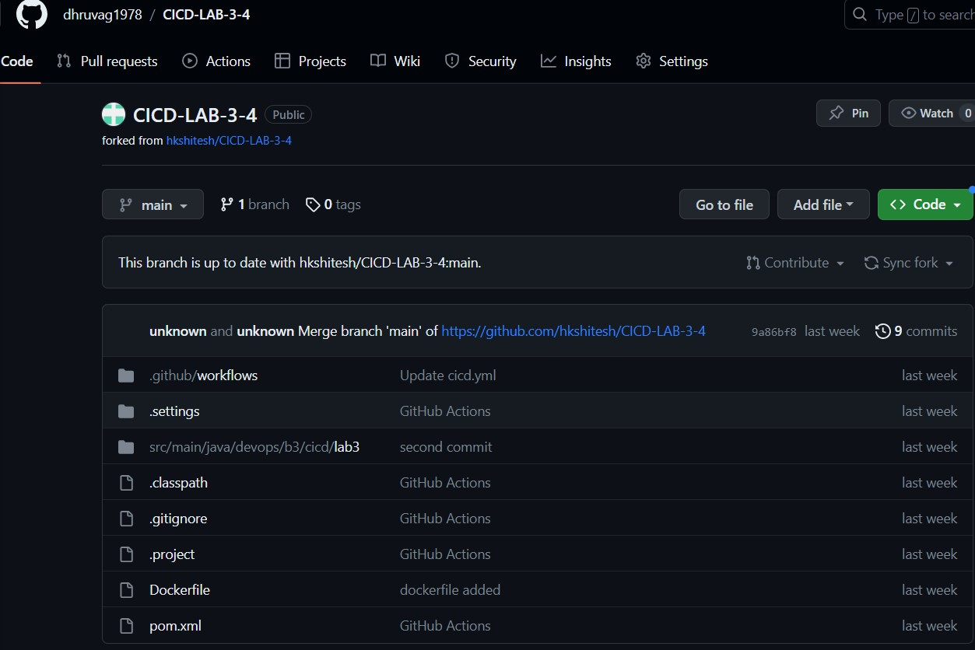

1. **Create a GitHub Actions Workflow name as cicd.yml and click on commit and push changes.**

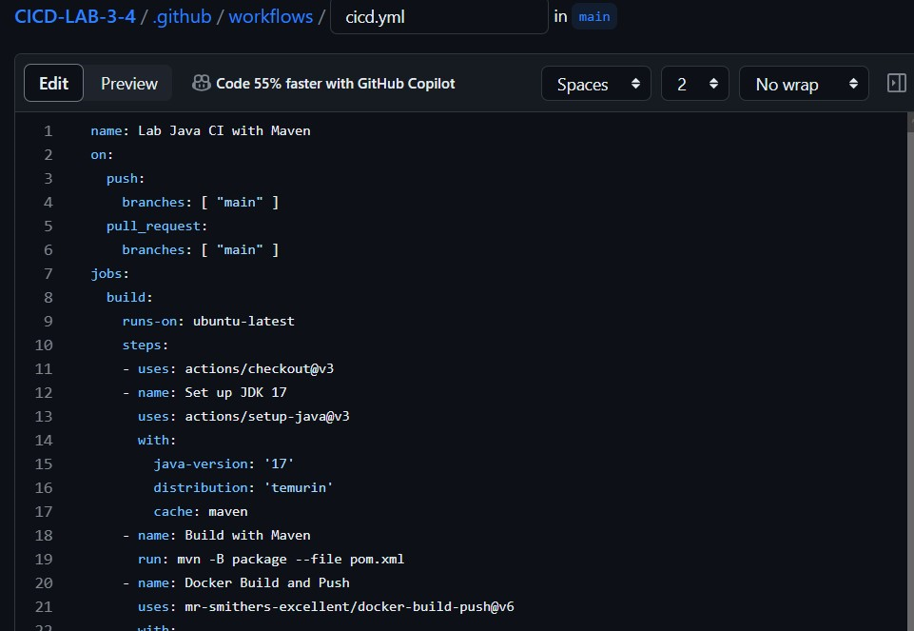

**3] Check the Workflow Status in that you will notices that our build has been completed and build images has been visible in our docker hub.**

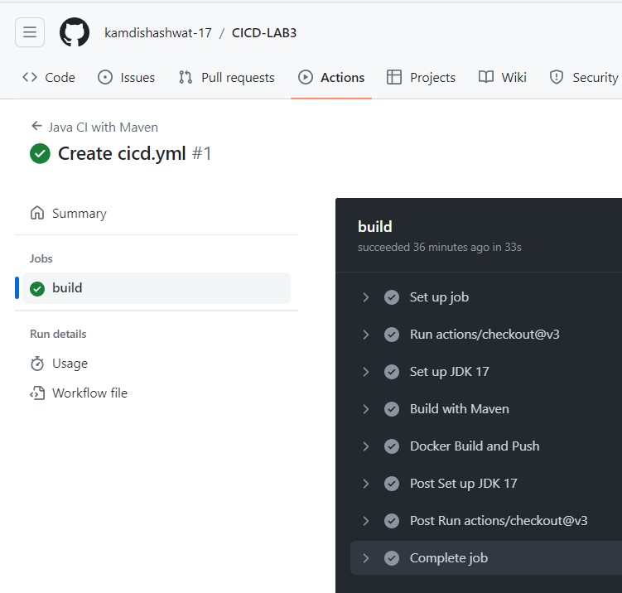

**4] Build image in docker hub**

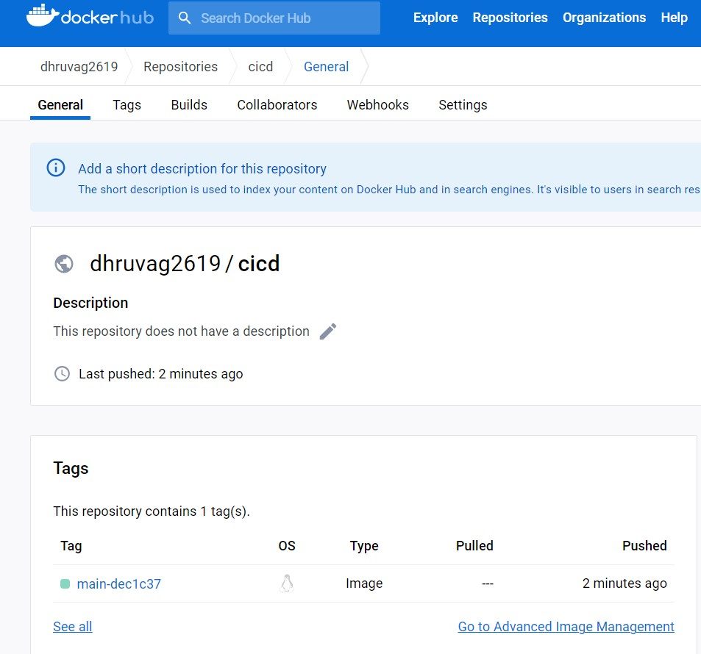

# EXPERIMENT – 4

**Aim: - Docker build and push using Github actions.**

1. **Add Docker Hub Credentials to GitHub Secrets**

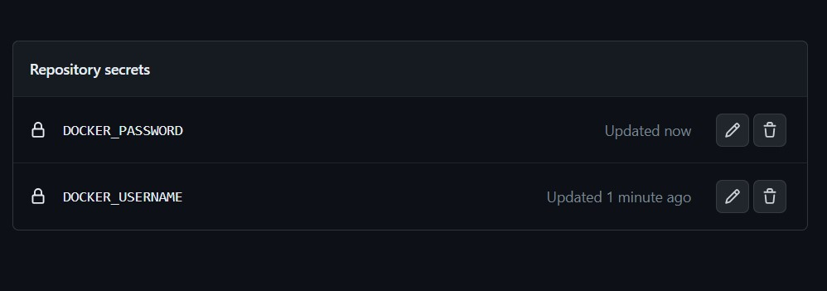

1. **Commit and Push Changes**

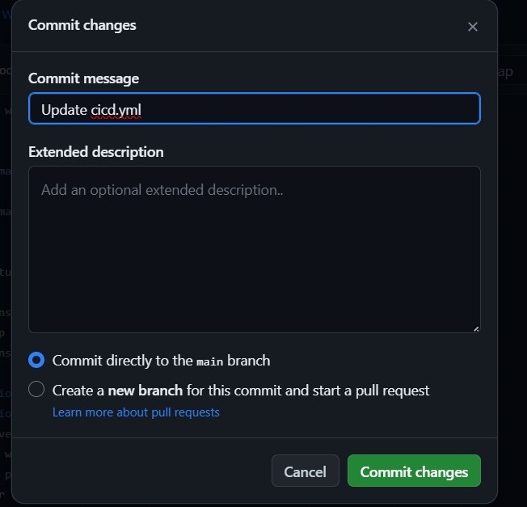

1. **Check the Workflow Status in that you will notices that our build has been completed and build images has been visible in our docker hub.**

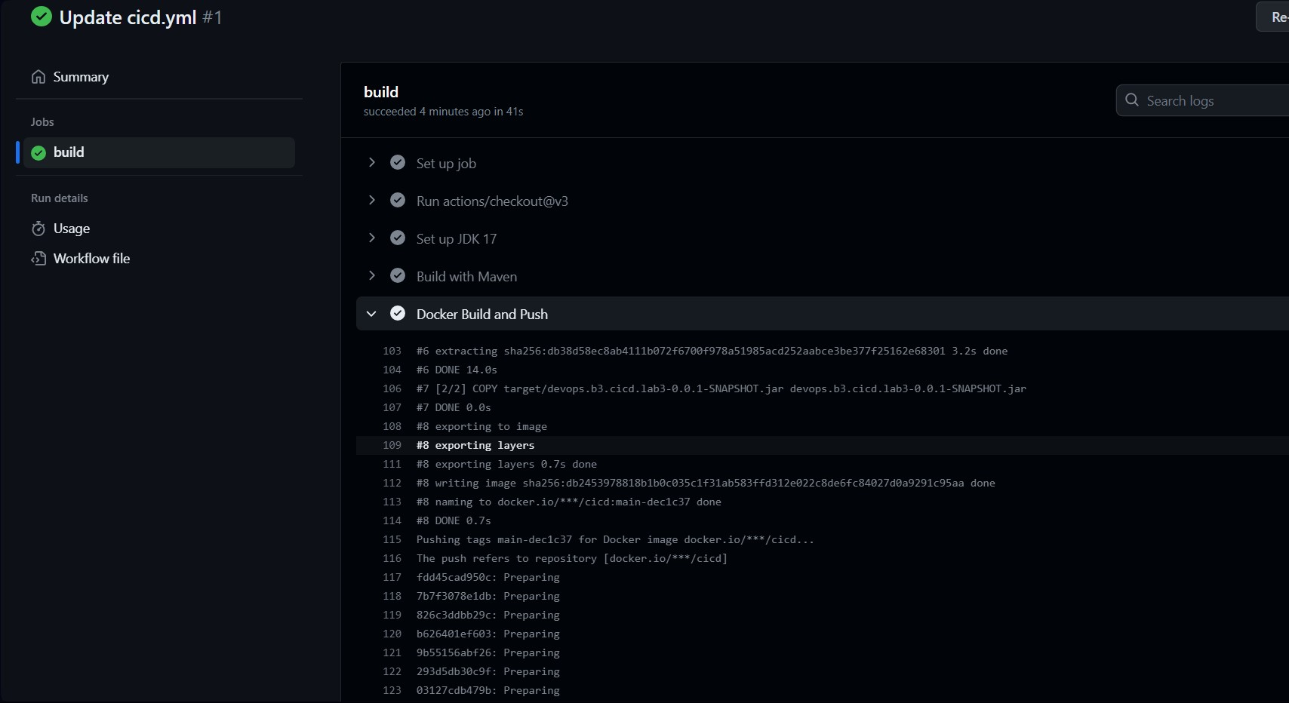

4] Build image in docker hub and docker command in a public view.

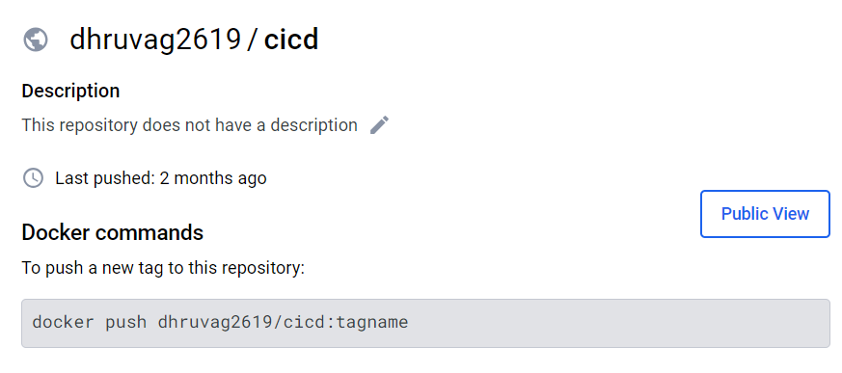

EXPERIMENT – 5

**Aim: Master/Slave concept in Jenkins**

1. Create Salve1 and Slave2 folder in your Local drive.

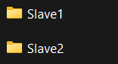

1. 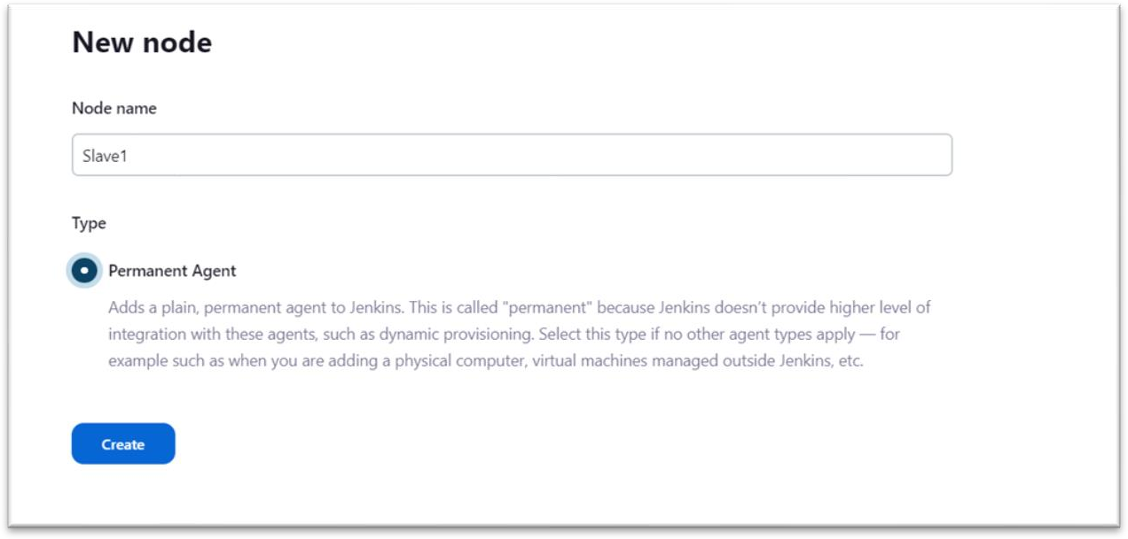Create a New Node and assign node name as Slave1.
2. Run Agent slave1 command on our command line windows.

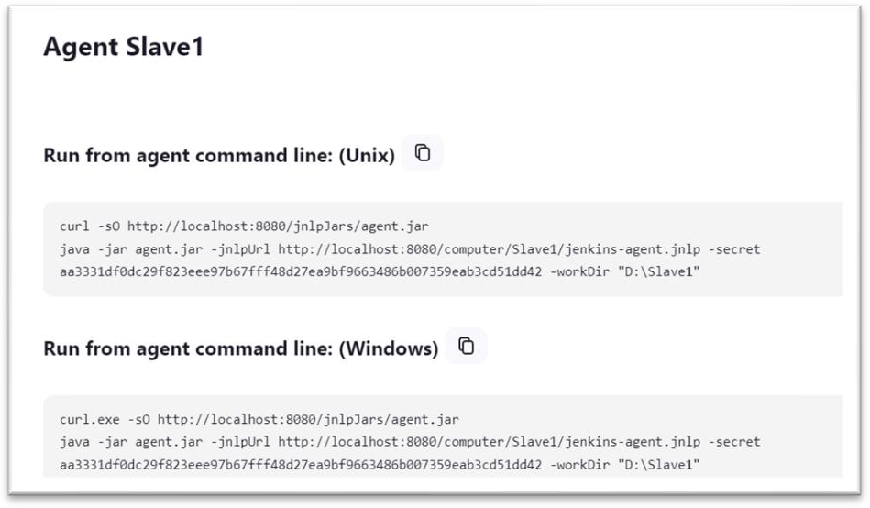

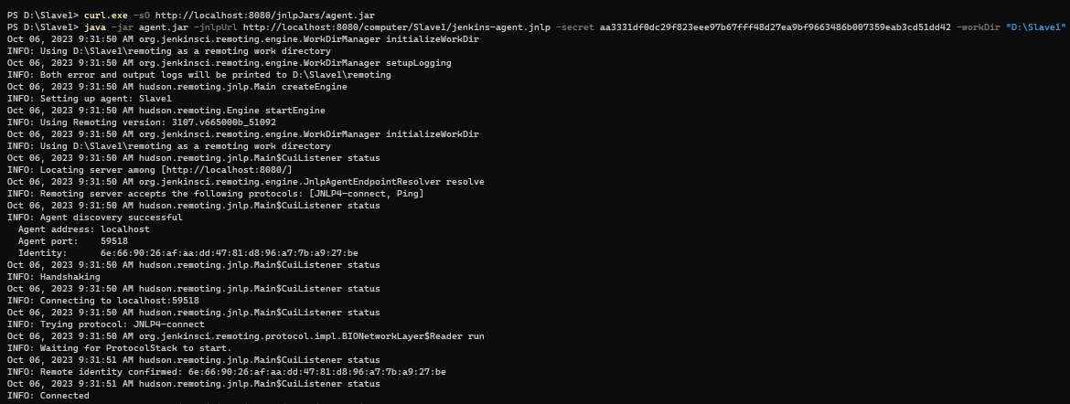

1. On your Jenkins create a new maven project name as cicd-lab5.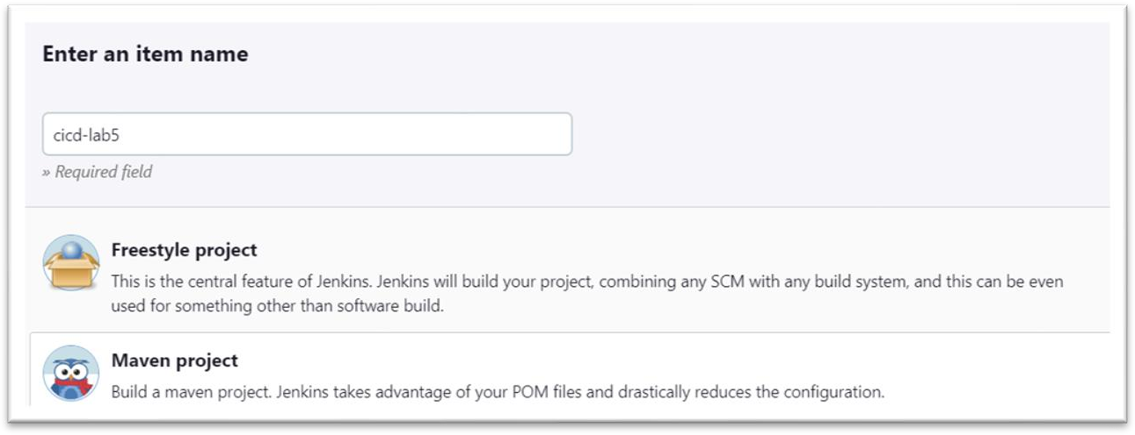

1. Configure it.

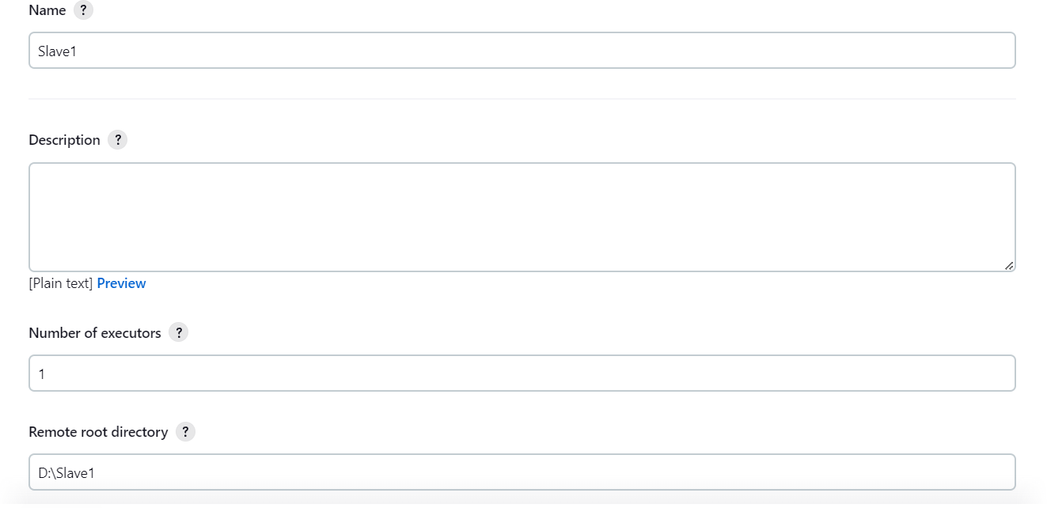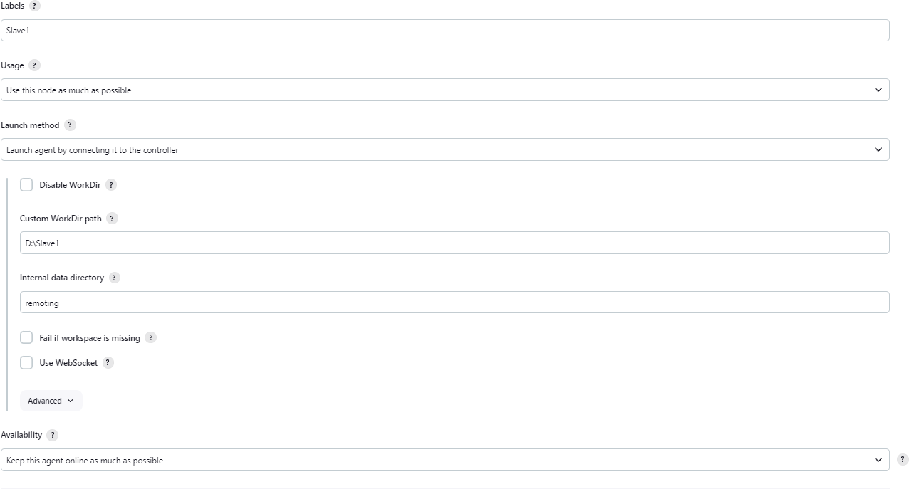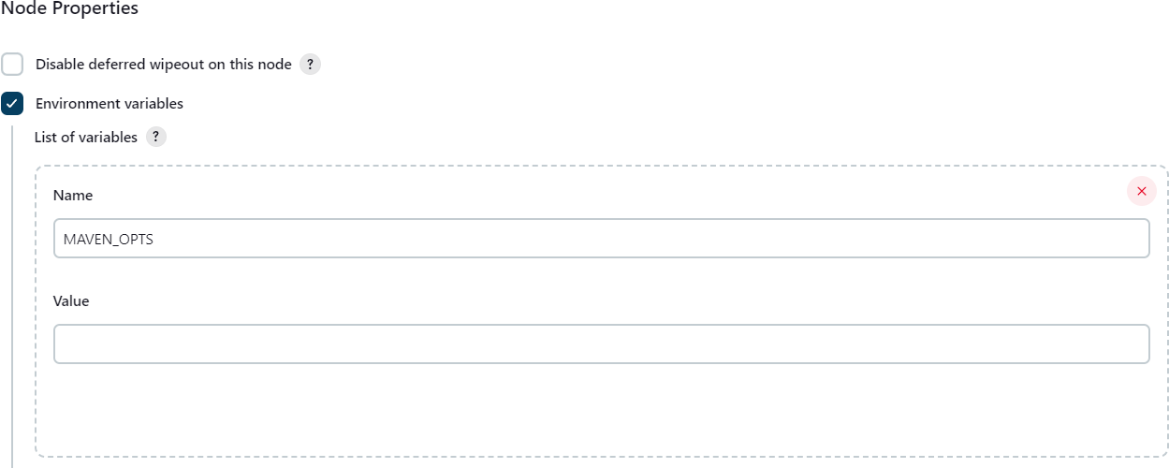

1. Make a build and check the output and Node.

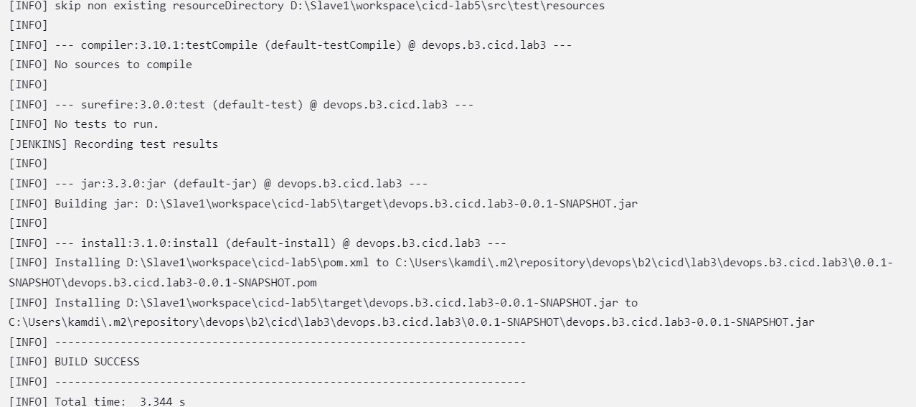

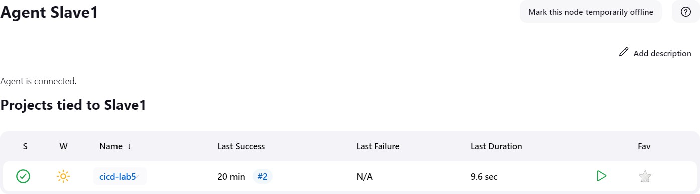

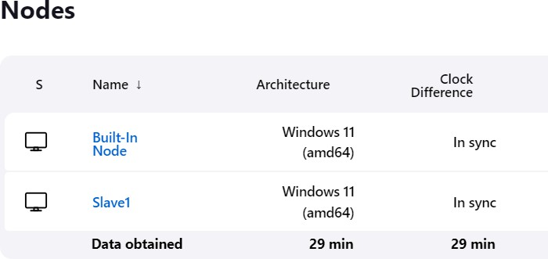

# EXPERIMENT – 6

### Aim: Job Chaining in Jenkins

1. Creating Jobs, such as Job1, Job2, Job3 to stimulate job chaining and sequential execution.

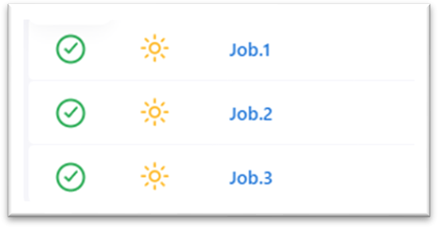

1. Configure Job Dependencies.

**Job.1 Configuration:**

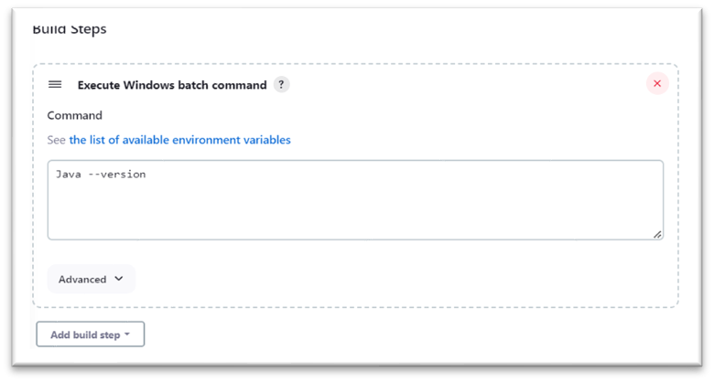

**Job.2 Configuration:**

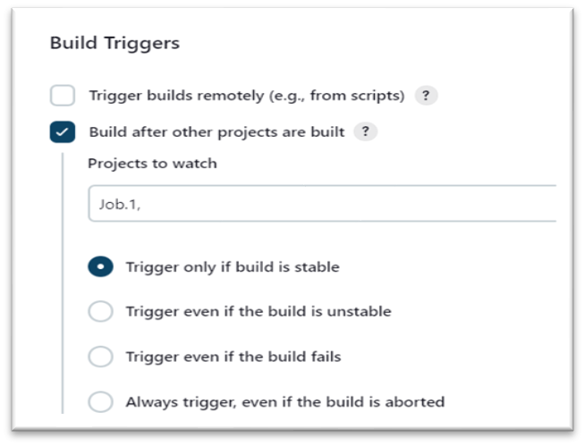

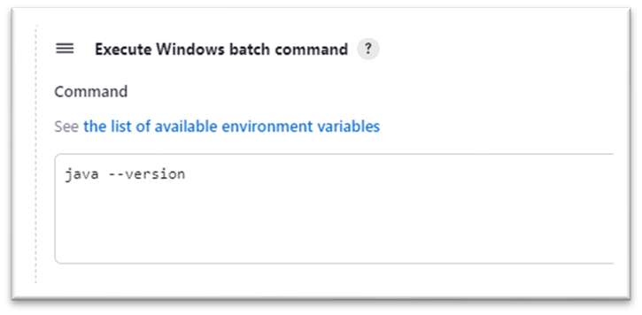

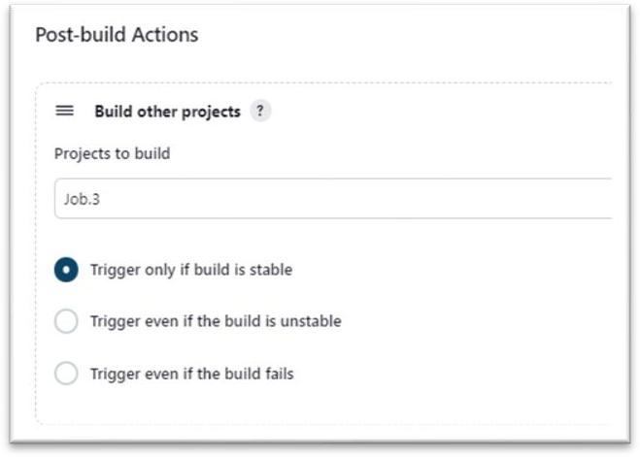

**Job.3 Configuration:**

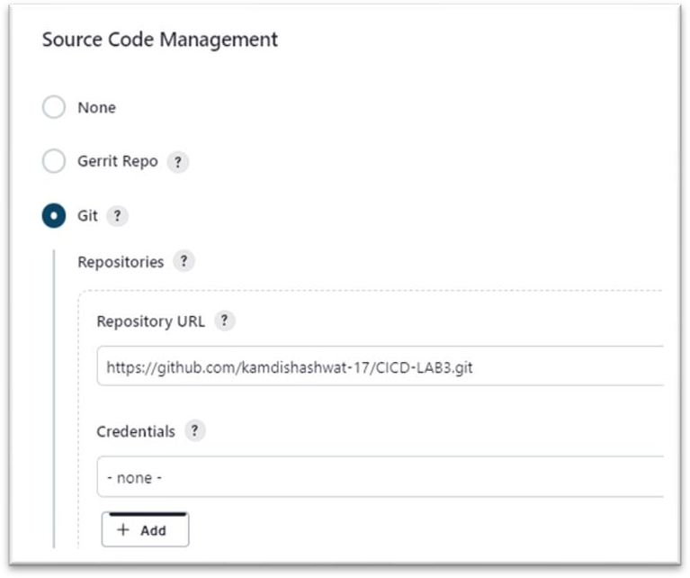

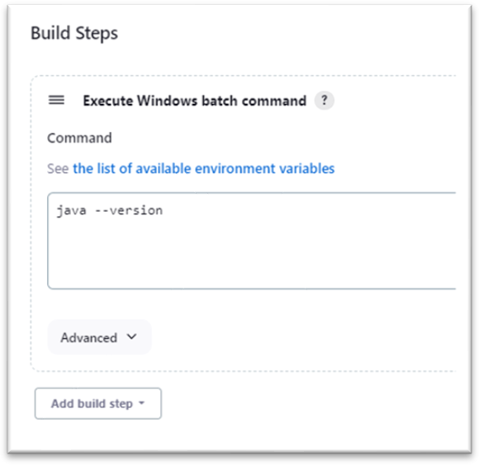

1. Setting Up Build Triggers and make the Build.

**Job.1: Job.2 :**

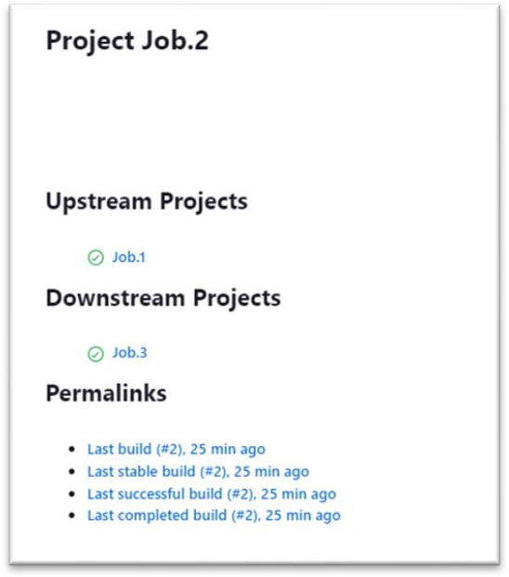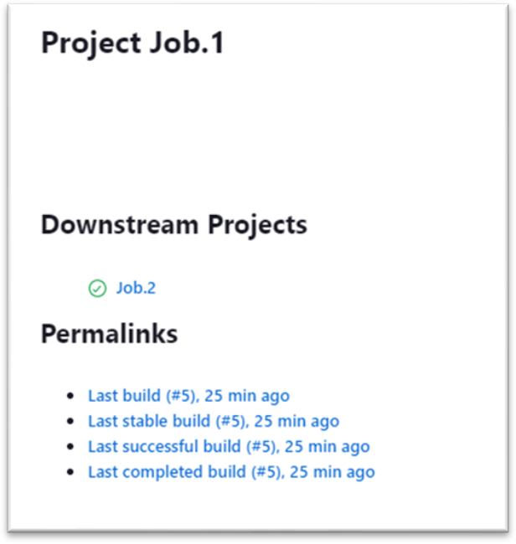

**Job.3:**

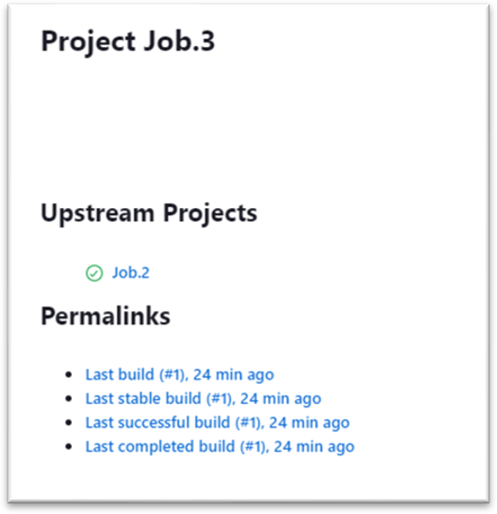

4] Viewing Console Output and Logs.

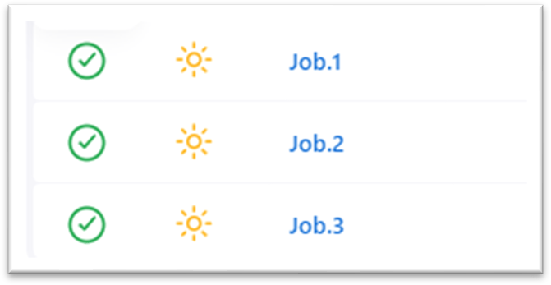

# EXPERIMENT – 7

### Aim: Email Notification in Jenkins

1. Create a “App Password” from our google account setting.

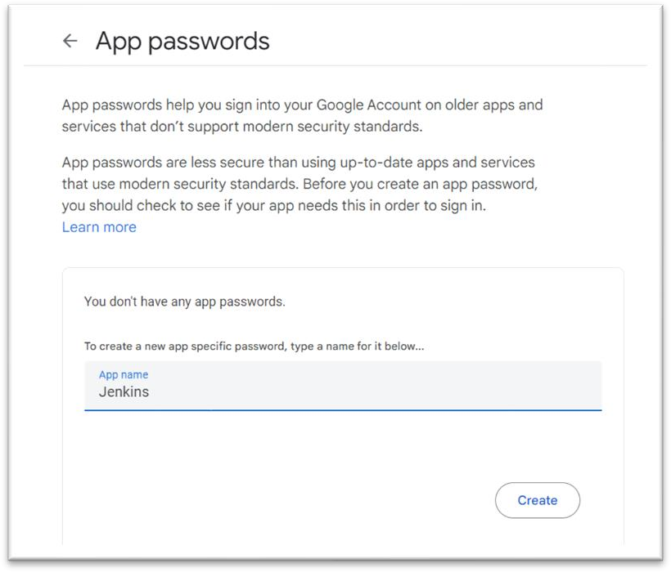

1. Installing Email Notification plugin.

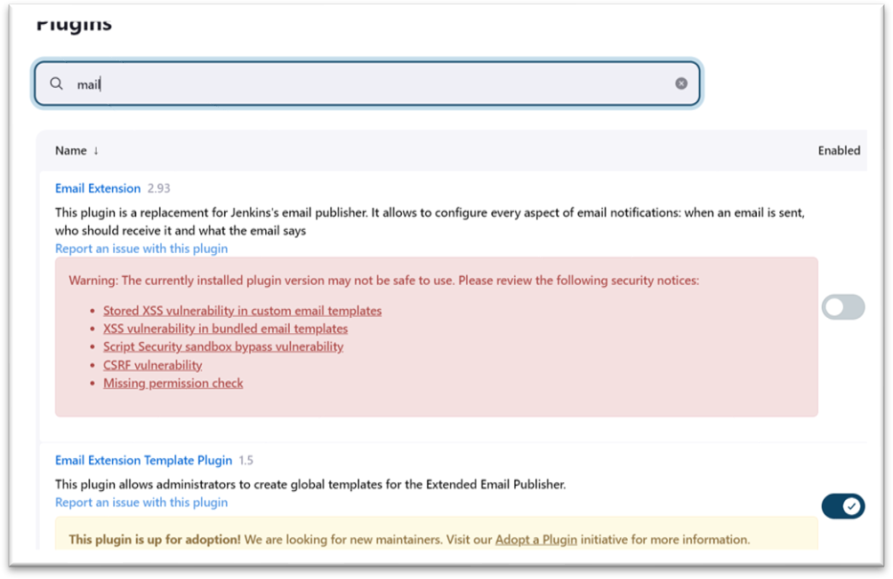

1. Configure SMTP Server by going to Dashboard > manage Jenkins > System > Email notification.

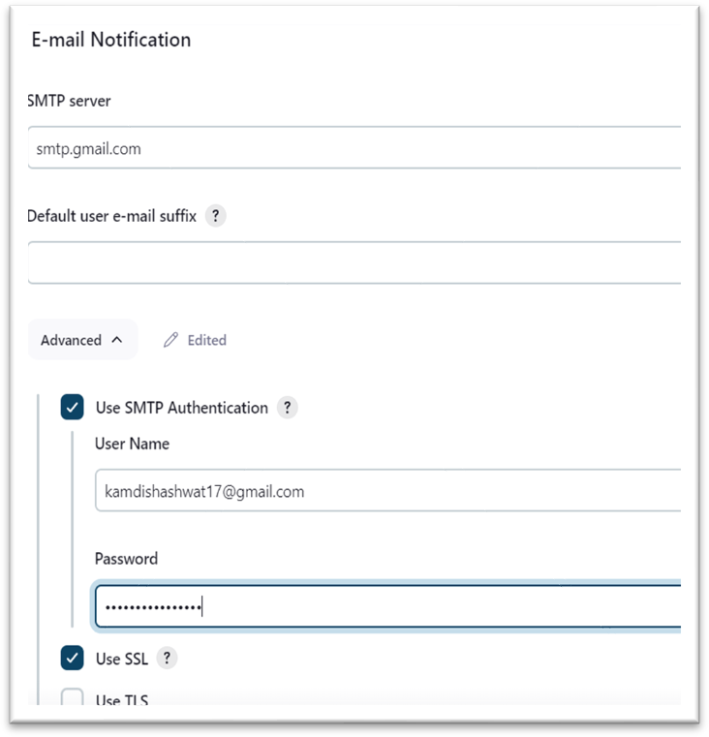

1. Create a maven project, configure it and make a build. safdgfhjgh

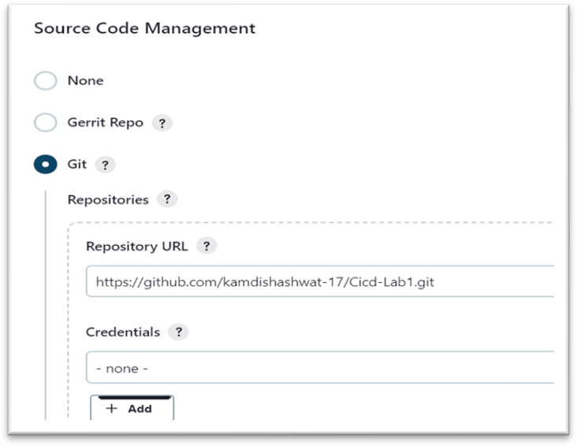

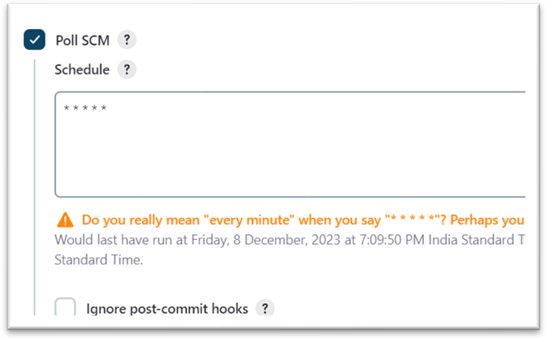

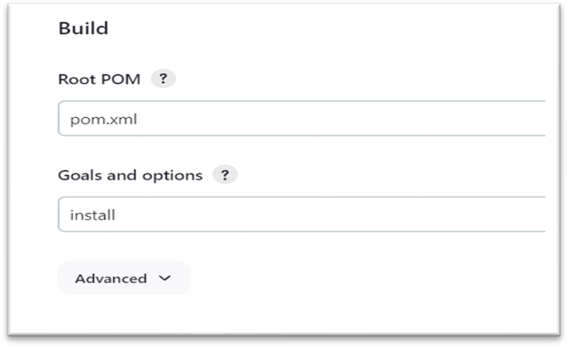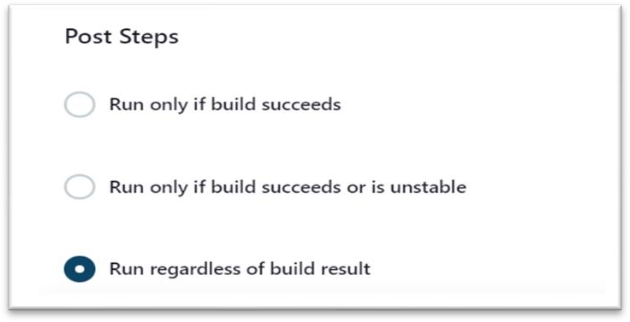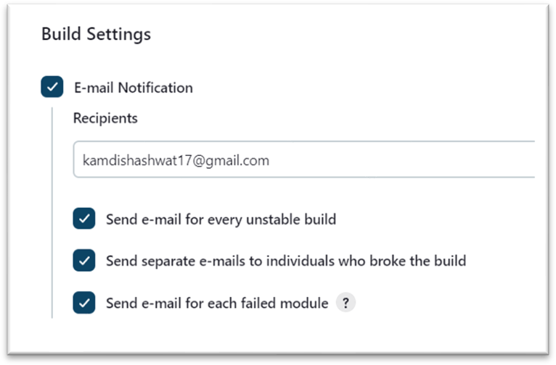

4] Check the Build and test the mail by intentionally failing a build.

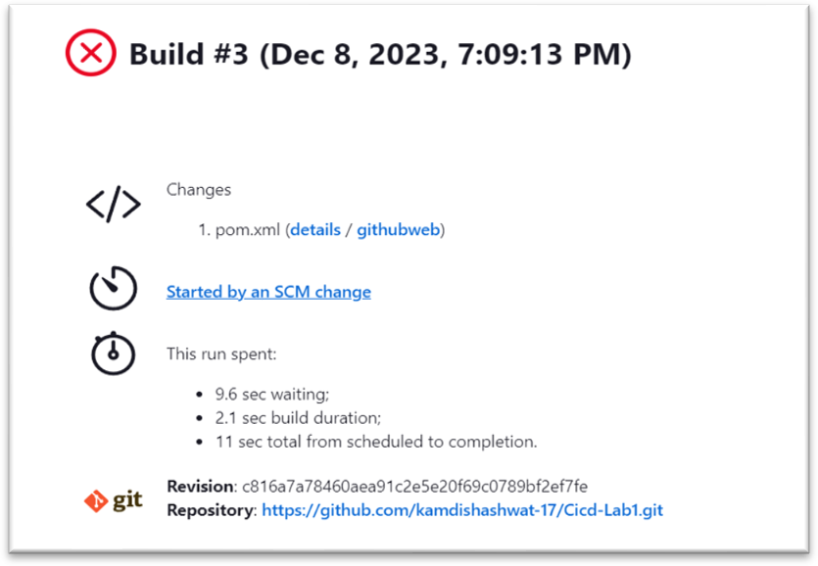

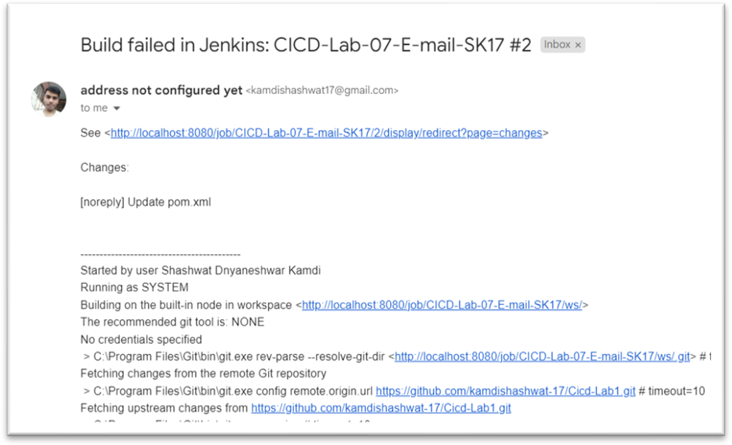

# EXPERIMENT – 8

### Aim: Remote Triggering of a Parameterized Build

1. Open manage Jenkins and install “Build with parameters” Plugin.

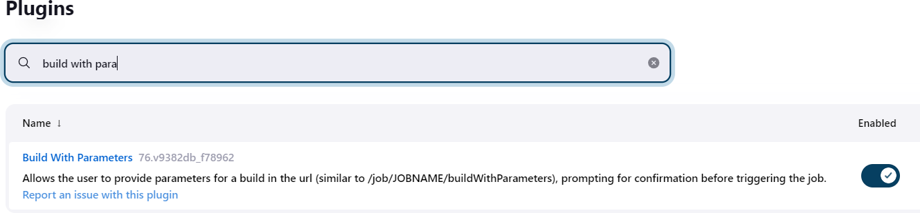

1. Select the **Freestyle project** as the build job type.

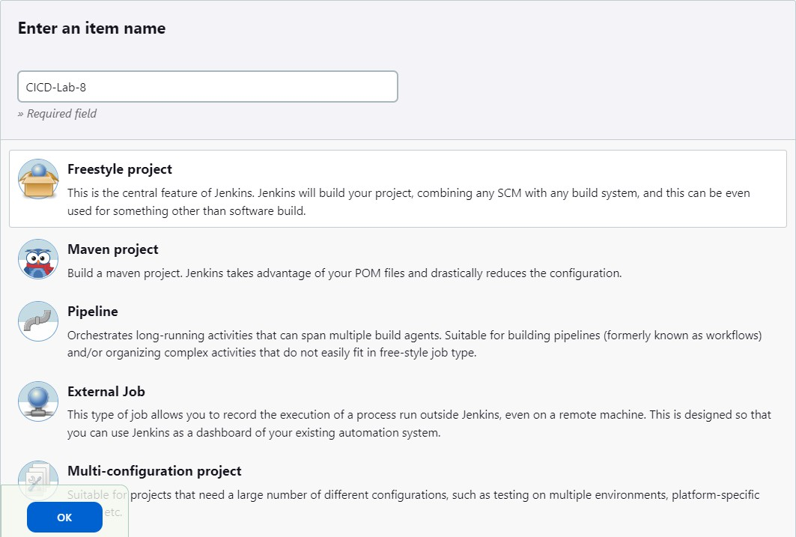

3] Configure as per Remote Triggering of a Parameterized Build.

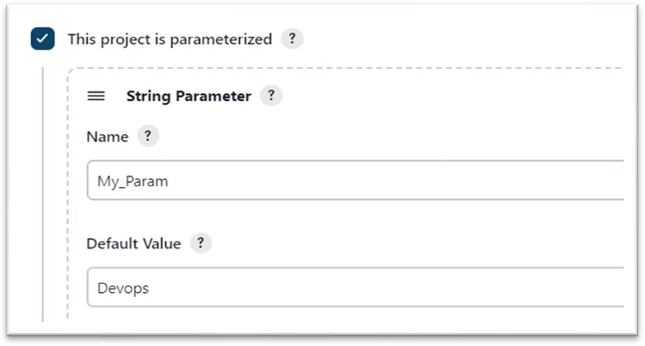

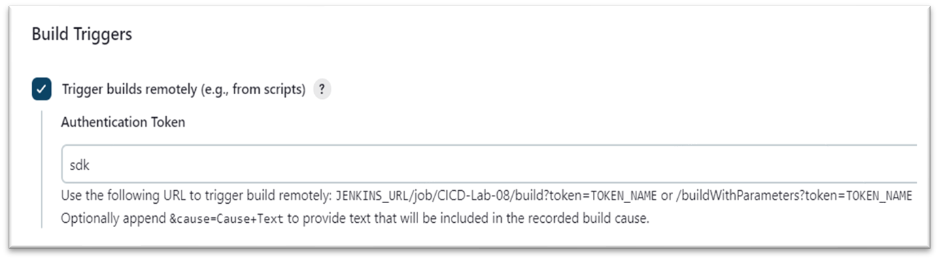

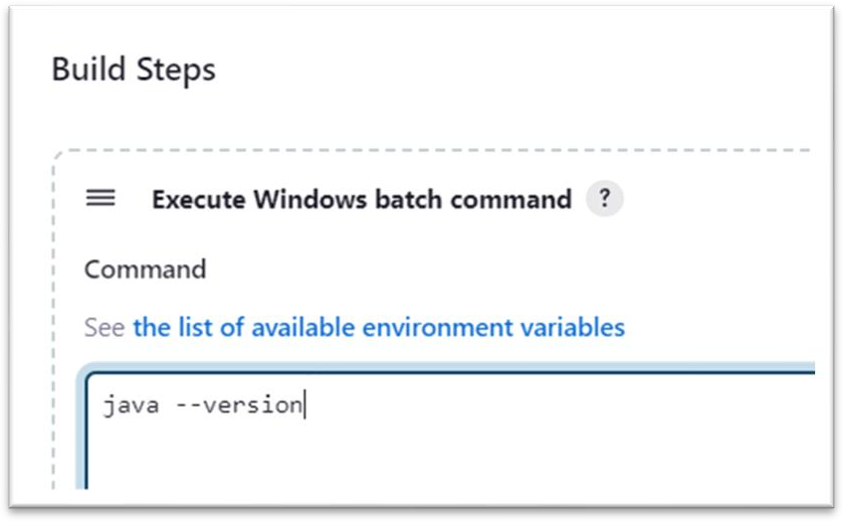

1. Configure Global Security.

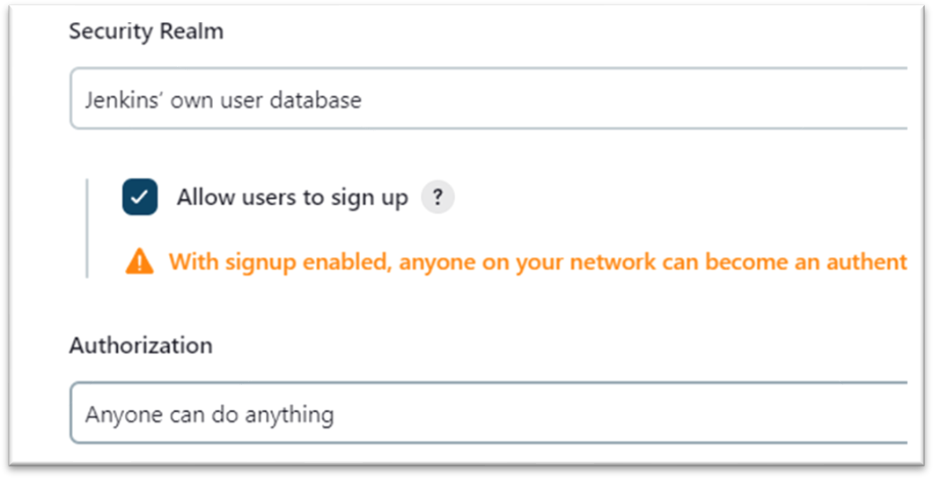

2] “curl -X GET <YourJenkinsJobUrl>/buildWithParameters?token=Sam”.Configure as per your URL and run it on Command Line.



1. Check the Console Output.

